WEEK 4

BANK DATABASE

(1BM21CS212)

Use bank_db;

--QUERY 1

select customer_name , count(distinct(ba.branch_name)) from depositer d,bankaccount ba,branch b

where d.acc_no =ba.acc_no AND ba.branch_name=b.branch_name and branch_city = 'delhi'

group by customer_name

having count(distinct ba.branch_name) = (select count(branch_name) from branch where branch_city = 'delhi');

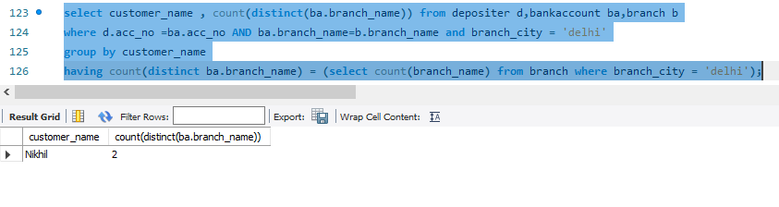

--QUERY2

update BankAccount

set balance=balance+(balance*0.05);

select balance from BankAccount;

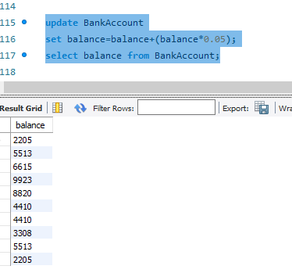

--QUERY3

select branch_name from branch

where assets > (select max(assets) from branch where branch_city = 'Bangalore');

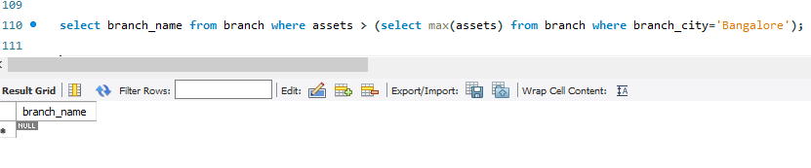

--QUERY4

--SPOT QUERY

select branch_name from branch

where assets > (select SUM(assets) from branch where branch_city = 'Bangalore');

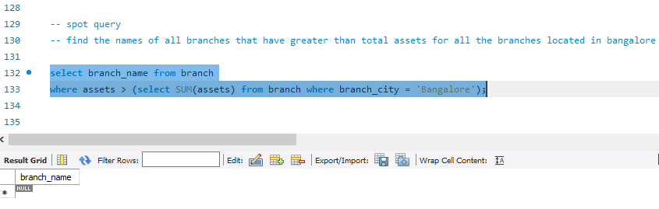

--QUERY5

delete from bankaccount where accno in (select a.accno from bankaccount a,branch b

where a.branch_name=b.branch_name and b.branch_city='Bangalore');

